Taylor Carrick TaylorLCarrick@gmail.com
3020 South Rutherford Blvd | Murfreesboro, TN 37130 615.710.5754
EDUCATION

Middle Tennessee State University Murfreesboro, TN (Fall 2019)
Bachelor of Science – Professional Computer Science Minors – Mathematics and Foreign Language: Japanese

Selected Courses: Languages: Applications:
Algorithms and Data Structures C++ GitHub
Assembly and Computer Organization Java GIMP
Compiler Design and Software Development HTML/CSS/Javascript GNU/Linux
Calculus III Microsoft Office
Advanced Japanese III

WORK EXPERIENCE

FedEx Lebanon, TN
EMR Techinician 01/2018 – 07/2018
- Modify bios settings
- Raid Setup
- Install hardware
- iDRAC management
- Imaging
- Package and label computers including additional peripherals

Honeywell/Viacom (NTT Data) Nashville, TN
IT Helpdesk Technician 01/2017 – 12/2017
- Use the Remedy and ServiceNow’s ticketing system and BT’s VoIP system.
- Troubleshoot Honeywell employee technology issues, such as assisting in password resets related to Active Directory, LDAP, and SAP.
- Assisted in migration from Office 2007 to O365.
- Remotely mapped network drives to install software, and guided users to request new hardware, software licenses, and various permissions.
- Contacted users through skype, phone, and email to follow-up on their issue and give additional assistance as needed for backlogged issues.

RESEARCH EXPERIENCE

FirstStep Game Development Team 05/2014 – 06/2014
- Used Autodesk Maya to create a 3D environment

FirstStep Mobile Robotics Research Team 05/2013 – 06/2013
- Team oriented project that measured signal range, quality, and the interference caused by different materials encountered in a commercial building environment.

AWARDS / CERTIFICATIONS / ACTIVITIES
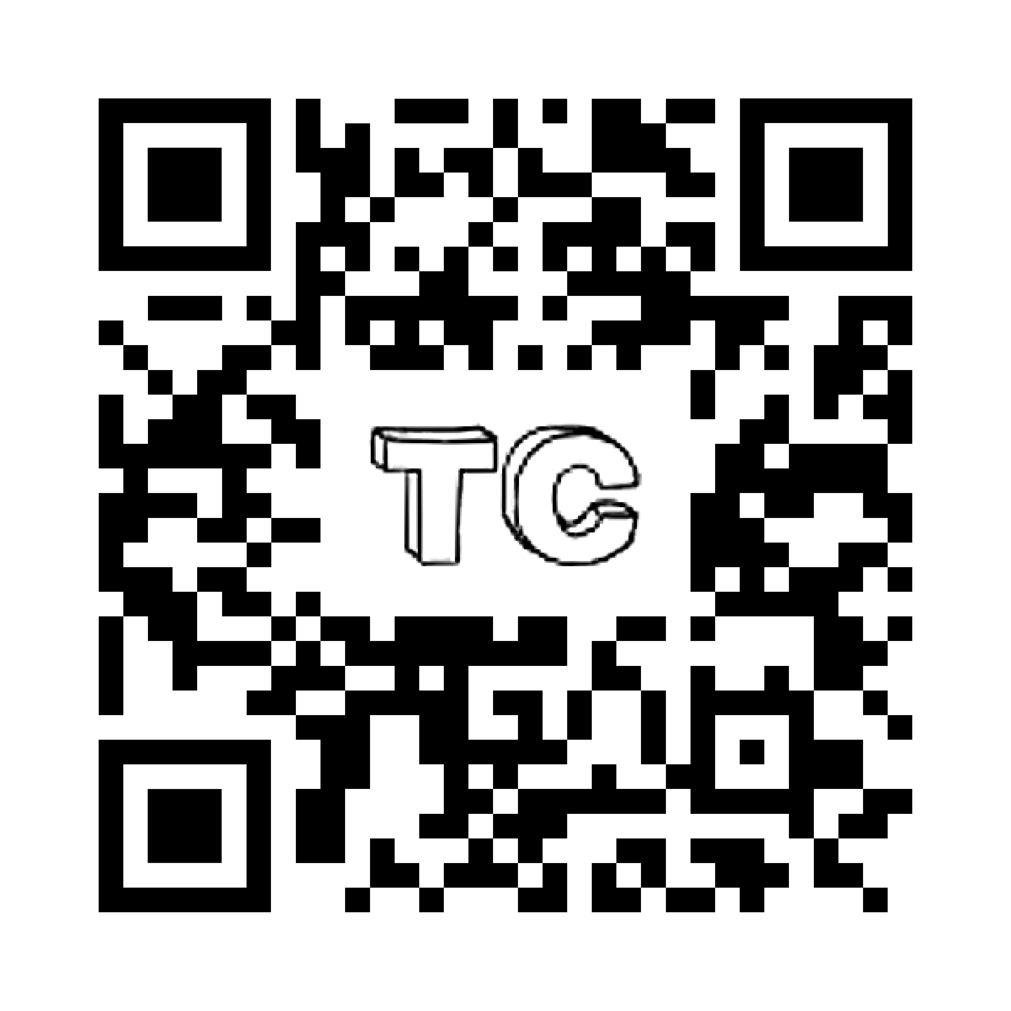
- Outstanding Freshman Award, For Outstanding Performance in Computer Science
- Microsoft Office Specialist 2016 Certification
- Member of ACM, Makers, and Computer Science Connections
- Actively learning Japanese and Mandarin Chinese
Taylor Lorian Carrick

REFERENCES:
Name: Steven Robert Sheffey II
Employer: IronNet Cybersecurity
Phone Number: 615-784-3198

Name: David Peranich
Employer: NTT Data
Phone Number: 205-821-2667

Name: Levi Madden
Employer: MTSU
Phone Number: 615-602-6891

